VISIT THE WHITNEY MUSEUM OF AMERICAN ART,
A MUST-SEE NEW YORK CITY DESTINATION

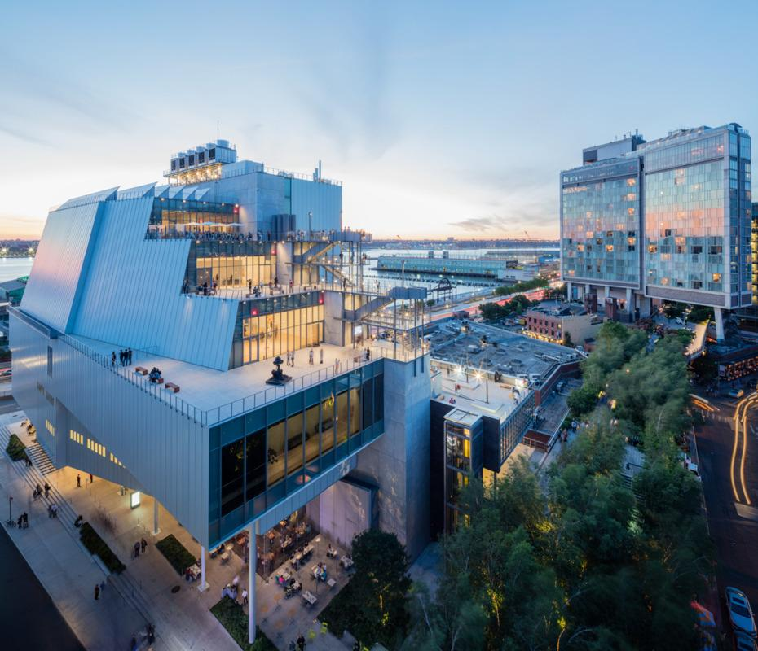

New York, NY, September 7, 2023 — Steps away from the High Line and Chelsea Market in New York City’s vibrant Meatpacking District, the Whitney Museum of American Art is the perfect destination for visitors of all ages to immerse themselves in art, culture, and all that NYC has to offer. The Whitney presents soaring views of the famous city skyline via four stories of outdoor balcony terraces and awe-inspiring architecture amid its collection of masterworks by leading American artists like Edward Hopper, Georgia O'Keeffe, Jacob Lawrence, along with cutting-edge exhibitions featuring today's most celebrated contemporary artists.

Masterpieces from the Whitney Collection
The Whitney houses the foremost collection of American art from the twentieth and twenty-first centuries, with a special focus on the most innovative artists of our time. Iconic works by Andy Warhol, Lee Krasner, Norman Lewis, Roy Lichtenstein, and many more are now on view in The Whitney’s Collection: Selections from 1900 to 1965. This multi-year presentation also features a panoramic installation of Alexander Calder’s Circus, which New York magazine calls “one of the most fun, beloved, and radical works of 20th-century American art.”

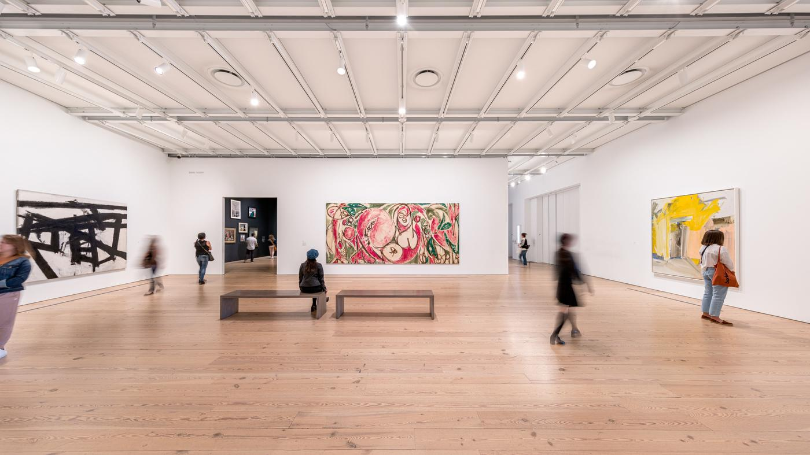

Current and Upcoming Exhibitions
On view through February 2024, Inheritance traces the profound impact of legacy across familial, historic, and aesthetic lines featuring new acquisitions and rarely seen works from the Whitney collection by forty-three leading artists. Opening this fall, Henry Taylor: B Side (October 4, 2023–January 2024) will celebrate an artist widely appreciated for his unique aesthetic, social vision, and freewheeling experimentation. Next spring, the Whitney Biennial, the Museum’s flagship exhibition and the country’s leading survey of contemporary American art, will return with a constellation of the most relevant art and ideas of our time. Opening in September 2024, Edges of Ailey will be the first large-scale museum exhibition to reflect on the life, work, and legacy of visionary artist Alvin Ailey. More information about the current and upcoming exhibitions can be found at whitney.org/exhibitions.

Whitney Biennial
March–August 2024
Don’t miss the art that everyone in New York City will be talking about next spring! The Whitney Biennial—a showcase of what’s new in the world of American art—returns to the Whitney for its 81st installment in 2024. A wide array of contemporary artists will participate in this visual, immersive story of America, sparking important conversations and giving visitors the opportunity to see tomorrow’s icons today, all in the heart of the electric Meatpacking District. More information about the Whitney Biennial can be found at whitney.org/biennial.

Family and Public Programs
All year round, the Whitney offers free art programming for kids and teens on weekends and a robust slate of public programs and events for visitors of all ages. Programs range from guided tours and artist talks to artmaking, performances, and so much more. This fall, drop by Halloween at the Whitney to enjoy artfully spooky activities. More public program information can be found online at whitney.org/events.

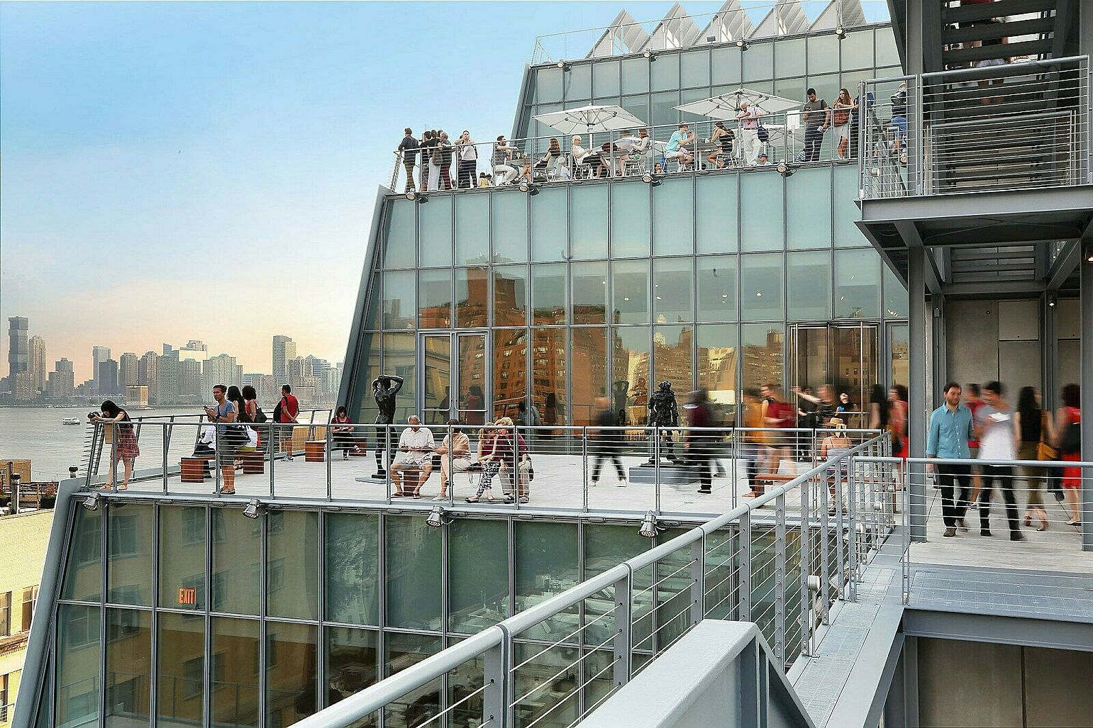

About the Whitney’s Building
The Whitney Museum of American Art's building in downtown Manhattan's Meatpacking District opened to the public on May 1, 2015. Designed by renowned architect Renzo Piano and situated on Gansevoort Street between the High Line elevated park and the Hudson River, the new building greatly increased the Whitney's exhibition and programming space, providing the most expansive view ever of its unsurpassed collection of modern and contemporary American art. The building features outdoor galleries with striking views of the city and state-of-the-art facilities for performance, film, video, and education programs.

About the Neighborhood
The Whitney is the cultural anchor of the Meatpacking District, a twenty-square-block area on the far West Side of Manhattan. A neighborhood where old New York meets the electric pace of the 21st century, today the Meatpacking District is bustling with numerous architecture and design firms, fashion boutiques, high-tech companies, innovative public parks, and some of New York's most notable restaurants, bars, clubs, and hotels. The neighborhood is bordered by Chelsea, renowned for its art galleries, cultural organizations, and Chelsea Market. The Whitney Museum of American Art is only a few steps from the High Line, one of New York City's most exceptional public parks located thirty feet above street level on a 1930s freight railway, as well as Little Island and Gansevoort Peninsula. Day and night, the cobblestone streets of the Meatpacking District are alive with culture. This fall, the Whitney will transform the artist Roy Lichtenstein’s nearby Greenwich Village studio into a new permanent home for its Independent Study Program (ISP), creating a dynamic space for creativity and scholarship.

PRESS CONTACT

For press materials and image requests, please visit our press site at whitney.org/press or contact:

Emma LeHocky, Senior Publicist
Whitney Museum of American Art
(212) 671-1844
Emma_LeHocky@whitney.org

Benjamin Lipnick, Assistant Director, Tourism
Whitney Museum of American Art
(646) 666-5525
Benjamin_Lipnick@whitney.org

Whitney Press Office
whitney.org/press
(212) 570-3633
pressoffice@whitney.org

ABOUT THE WHITNEY
The Whitney Museum of American Art, founded in 1930 by the artist and philanthropist Gertrude Vanderbilt Whitney (1875–1942), houses the foremost collection of American art from the twentieth and twenty-first centuries. Mrs. Whitney, an early and ardent supporter of modern American art, nurtured groundbreaking artists when audiences were still largely preoccupied with the Old Masters. From her vision arose the Whitney Museum of American Art, which has been championing the most innovative art of the United States for ninety years. The core of the Whitney’s mission is to collect, preserve, interpret, and exhibit American art of our time and serve a wide variety of audiences in celebration of the complexity and diversity of art and culture in the United States. Through this mission and a steadfast commitment to artists, the Whitney has long been a powerful force in support of modern and contemporary art and continues to help define what is innovative and influential in American art today.
Whitney Museum Land Acknowledgment
The Whitney is located in Lenapehoking, the ancestral homeland of the Lenape. The name Manhattan comes from their word Mannahatta, meaning “island of many hills.” The Museum’s current site is close to land that was a Lenape fishing and planting site called Sapponckanikan (“tobacco field”). The Whitney acknowledges the displacement of this region’s original inhabitants and the Lenape diaspora that exists today.
As a museum of American art in a city with vital and diverse communities of Indigenous people, the Whitney recognizes the historical exclusion of Indigenous artists from its collection and program. The Museum is committed to addressing these erasures and honoring the perspectives of Indigenous artists and communities as we work for a more equitable future. To read more about the Museum’s Land Acknowledgment, visit the Museum’s website.

VISITOR INFORMATION
The Whitney Museum of American Art is located at 99 Gansevoort Street between Washington and West Streets, New York City. Public hours are Monday, Wednesday, and Thursday, 10:30 am–6 pm; Friday, 10:30 am–10 pm; and Saturday and Sunday, 10:30 am–6 pm. Closed Tuesday. Visitors eighteen years and under and Whitney members: FREE. Admission is pay-what-you-wish on Fridays, 7–10 pm. Groups of ten or more enjoy discounted admission rates when they reserve in advance, and may request a private guided tour of the permanent collection or a special exhibition for an additional fee. COVID-19 vaccination and face coverings are not required but strongly recommended. We encourage all visitors to wear face coverings that cover the nose and mouth throughout their visit.
Image captions:
Whitney Museum of American Art. Photograph by Ben Gancsos
Whitney Museum of American Art. Photograph by Max Touhey
Whitney Museum of American Art. Photograph by Nic Lehoux

###

